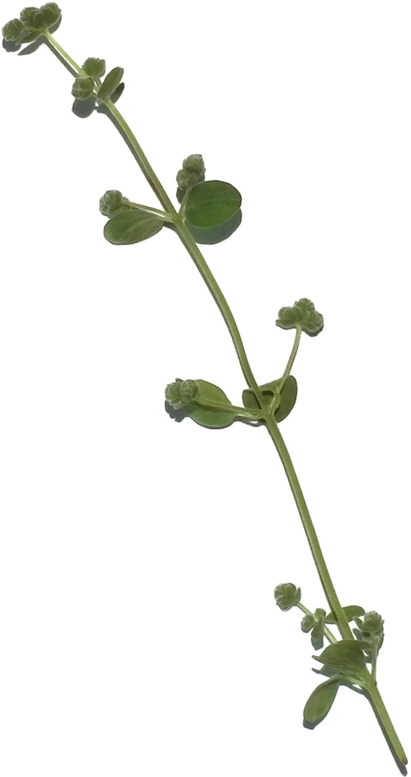

RECIPES

Salt & vinegar roasted potatoes

**Page 1**

Easter salad with avocado, sweet peas, and lemon vinaigrette

**Page 2**

Shaved brussels sprout salad with currants and bacon vinaigrette

**Page 3**

Meyer lemon pasta with mustard seed and turmeric

**Page 4**

Rosemary peppercorn fizz

**Page 5**

My grandmother’s date bars

**Page 6**



Find more at 1000threadsblog.com

RECIPES

ENJOY!

**Shaved brussels sprout salad with currants and bacon vinaigrette**

5 slices bacon, chopped  
1/2 cup sherry vinegar  
2 tablespoons Dijon mustard  
2 cups brussels sprouts, shaved  
1/2 red onion  
1/4 cup halved toasted hazelnuts  
2 tablespoons dried currants  
Cracked black pepper, to taste  
Salt, to taste  
Shaved parmigiano-reggiano

For the dressing:  
Cook bacon in a skillet until crisp. Remove bacon, leaving drippings in skillet, and set aside on a paper towel. While drippings are still hot, mix sherry vinegar and mustard in the pan to combine. Salt and pepper to taste.

For the salad:  
Layer brussels sprouts, red onion, hazelnuts, currants, and bacon on two salad plates. Top with parmigiano-reggiano and cracked pepper. Serve with dressing on the side, or dress and serve immediately.

**Salt & vinegar roasted potatoes**

2 pounds red bliss potatoes, cut in half  
1 cup plus 2 tablespoons malt vinegar  
1 tablespoon coarse salt  
1 tablespoon (or more) maldon salt  
2 tablespoons olive oil  
1 tbls fresh chopped rosemary

Preheat oven to 400 degrees.

Boil potatoes, vinegar and coarse salt in 5 cups water for 20 minutes or until soft but firm.

Drain potatoes, toss in oil and bake on a flat sheet until crisp.

While still hot, but just before serving, toss crisp potatoes in vinegar and herbs. Coat with maldon salt, to taste.

**Easter salad with avocado, sweet peas, and lemon vinaigrette**

For Salad  
1 head baby broccoli, trimmed  
1 avocado, cubed  
1/2 cup baby arugula  
1/2 cup flat leaf parsley  
1/2 cup sweet pea shoots  
1/2 cup mixed sprouts  
1/4 cup sweet peas  
1/4 cucumber, peeled and cubed  
1/4 cup crumbled fresh feta (or more, to your liking)  
Juice of half a lemon  
Fresh cracked pepper

For Dressing  
1 shallot  
3/4 cup olive oil  
2 tablespoons dijon mustard  
Juice of one lemon  
Salt and pepper to taste

Blend ingredients for dressing until smooth and thick.

In a large bowl, toss all ingredients for salad, setting aside feta and avocado. Place salad in a serving bowl and add feta and avocado on top. Finish with freshly cracked black pepper and serve with dressing on the side.

**Meyer lemon pasta with mustard seed and turmeric**

4 tablespoons oil oil  
1 tablespoons mustard seeds  
2 large cloves garlic  
2″ piece freshly peeled turmeric, grated  
1/2 cup and 2 tbls cream  
1 meyer lemon  
2 tablespoons chopped flat leaf parsley  
Cracked pepper, to taste  
Salt, to taste

Over medium high heat, cook mustard seed and oil in a covered sauté pan. Sauté until the seeds pop.

Reduce heat to medium and add garlic. Sauté for a minute before adding turmeric. Sauté contents for an additional minute to bring out the flavor of the turmeric, then add cream, salt, and pepper.

Reduce sauce by a 1/4 and remove from heat.

Allow the sauce to cool slightly before adding lemon and parsley, so as to not wilt the parsley and bitter the lemon.

Pour over prepared pasta, and fall in love.

**Rosemary peppercorn fizz**  
Makes one drink.

6 blackberries  
1 1/2 oz. gin  
3/4 oz. lime juice  
1/2 oz. rosemary peppercorn simple syrup  
club soda  
ice

Muddle blackberries in the bottom of a glass. Add ice, then gin, lime juice, and simple syrup. Top with club soda and garnish with a sprig of rosemary. Stir before drinking.

**Rosemary peppercorn simple syrup**

1 cup sugar  
1 cup filtered water  
8 peppercorns  
2 sprigs rosemary

Bring sugar and water to a boil. Allow sugar to dissolve, then add rosemary and peppercorns. Let boil for one minute, then remove from heat. Let syrup cool.

Transfer cooled syrup to a glass container for storage. Strain before using.

**My grandmother’s date bars**  
1/2 recipe for a big batch, whole recipe for a huge batch

3 1b dates, pitted and chopped  
1 cup water  
2 cups granulated sugar  
2 cups brown sugar  
1 cup butter  
1 cup shortening (or 1 additional cup butter — I usually stick with butter)  
1 cup warm water  
2 teaspoons baking soda  
5 cups oats (not quick)  
5 cups flour

Preheat oven to 400 degrees.

Cook dates, water, and granulated sugar in a saucepan over medium-high heat until the mixture begins to form a paste. Set aside to cool.

Mix remaining ingredients in a medium-sized bowl. Press half oat mixture evenly into the bottom of a cookie sheet (or for a full batch, 2 cookie sheets). Spread date mixture over, then cover with remaining oat mixture.

Bake 15 minutes or until just golden brown.